**

Head Admin MICRA Login

Head Admin Forgot Password

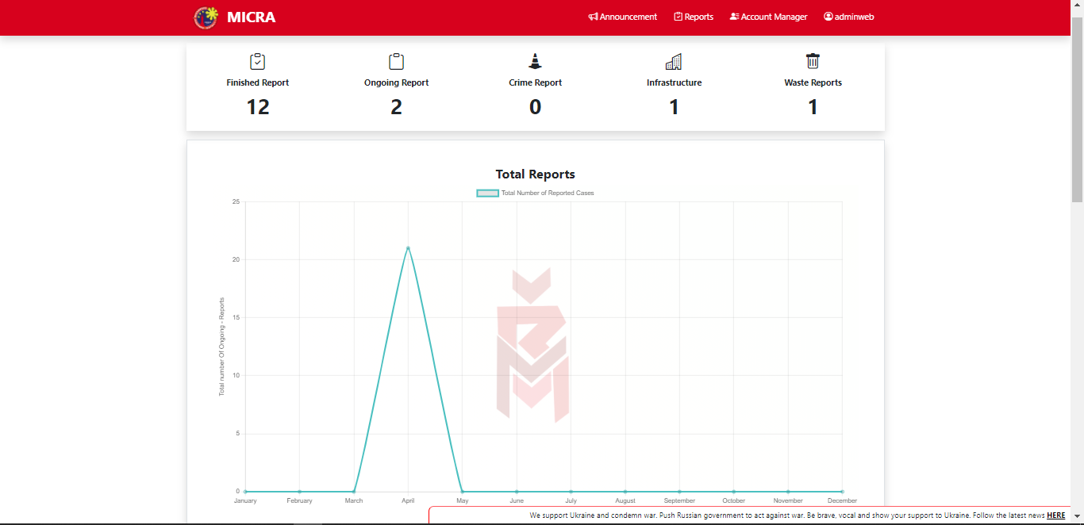

Head Admin Total Reports

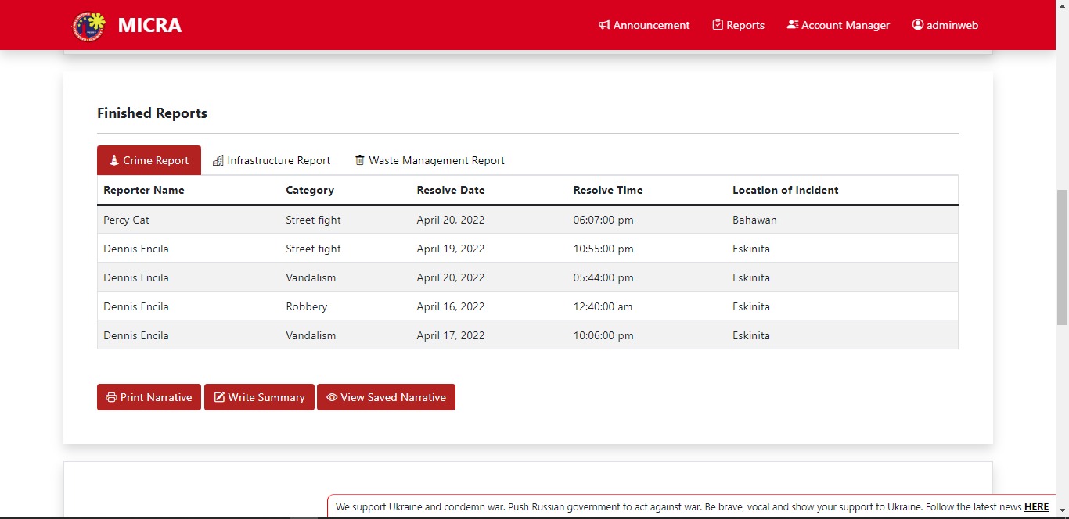

Head Admin Finished Reports

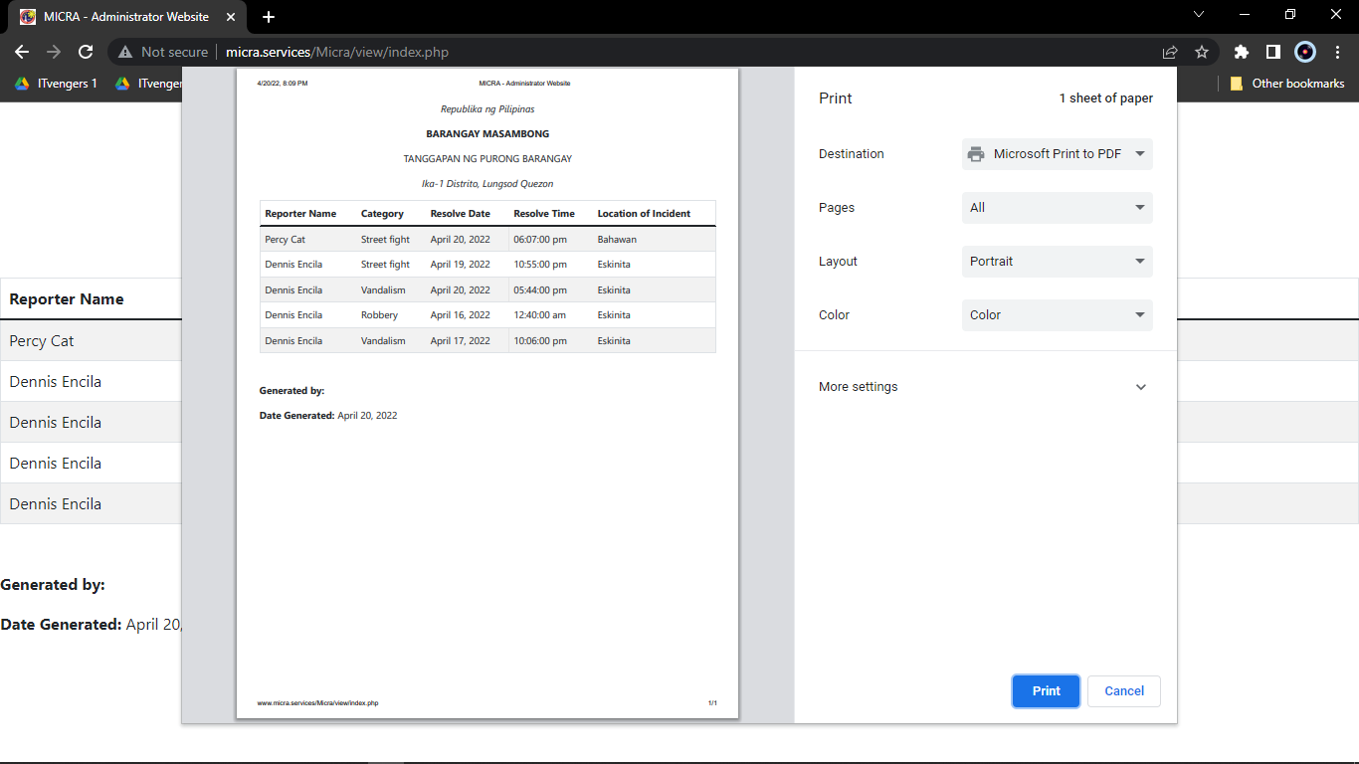

Head Admin Print Narrative

Head Admin Write Narrative Report

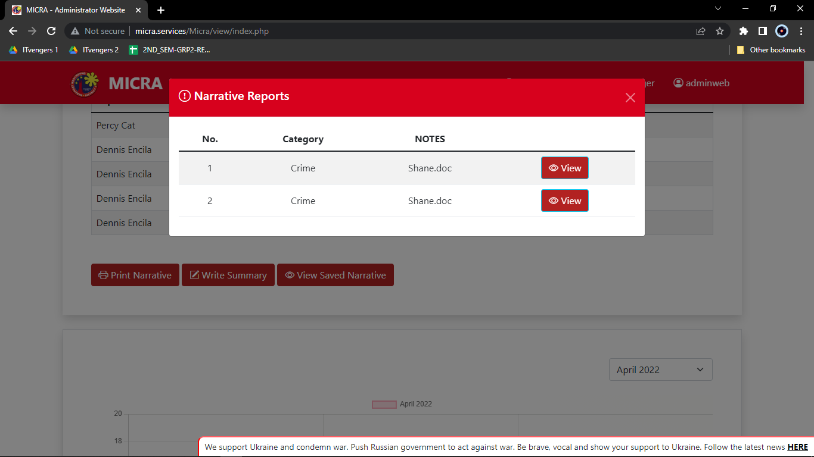

Head Admin Narrative Report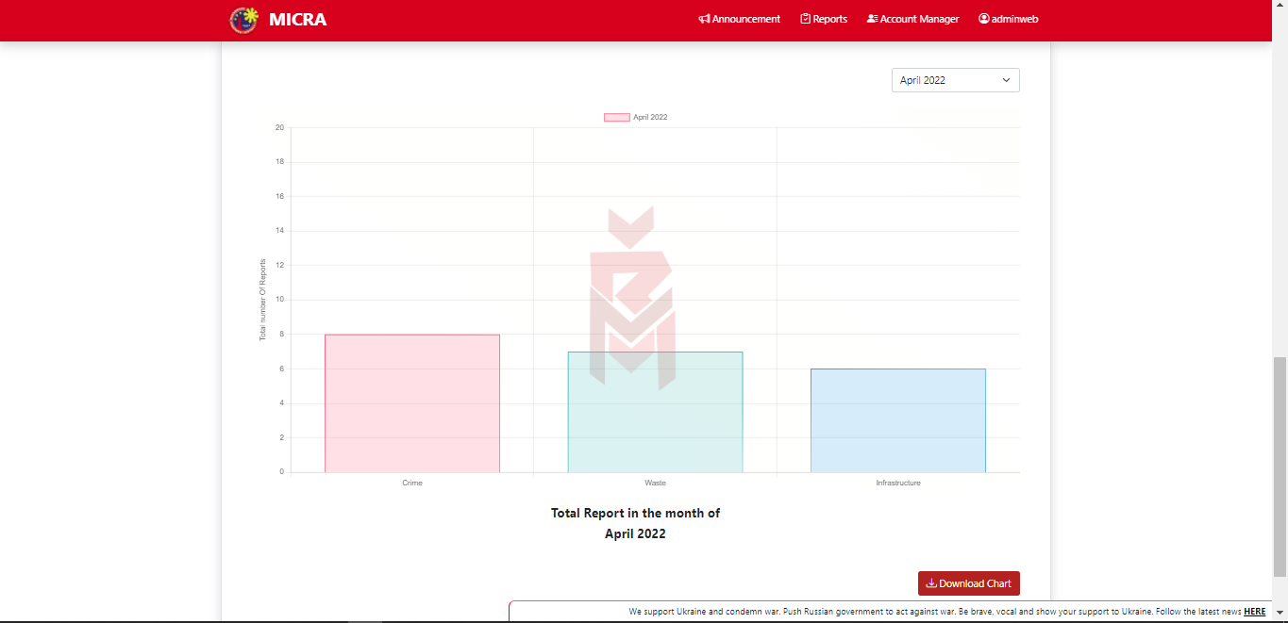

Head Admin Print Analytics

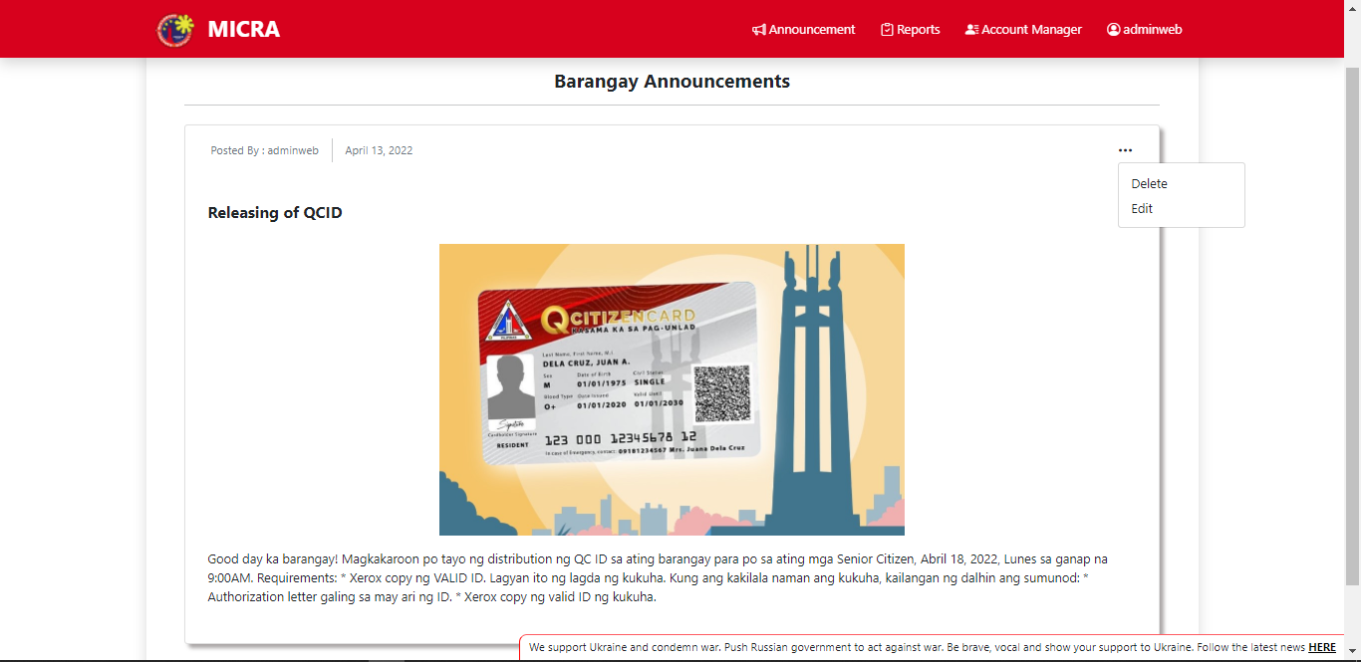

Head Admin Manage Announcement

Head Admin Create New Announcement

Head Admin Ongoing Reports for Waste Management

Head Admin Report Logs for Infrastructure

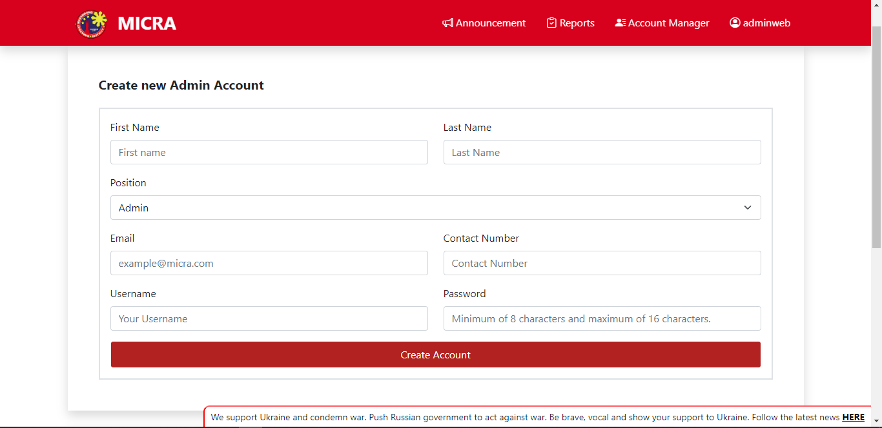

Head Admin Administrator Account

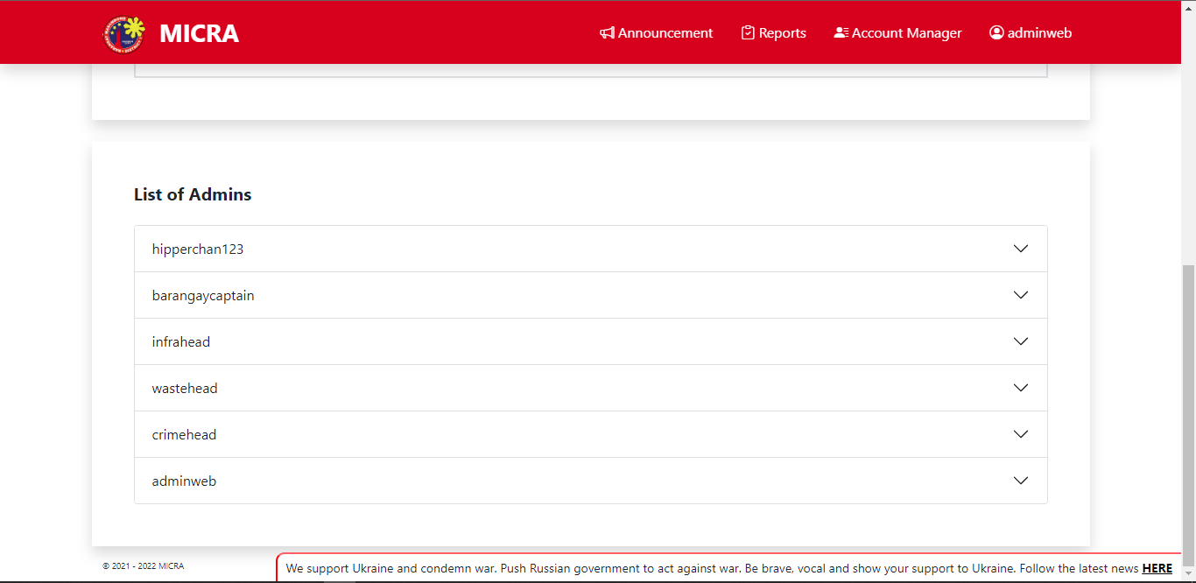

Head Admin List of Admins

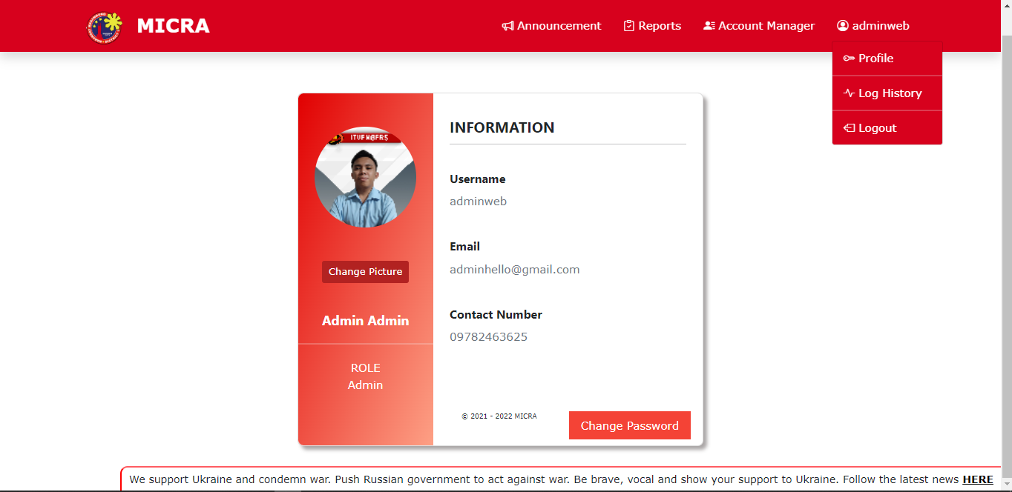

Head Admin Profile

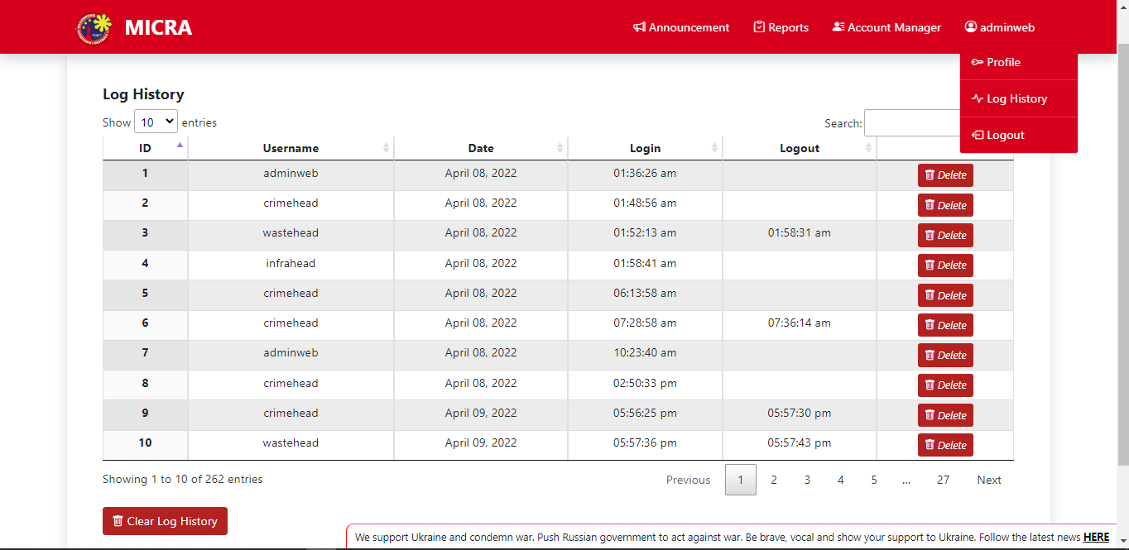

Head Admin Log History

**For Barangay Captain**

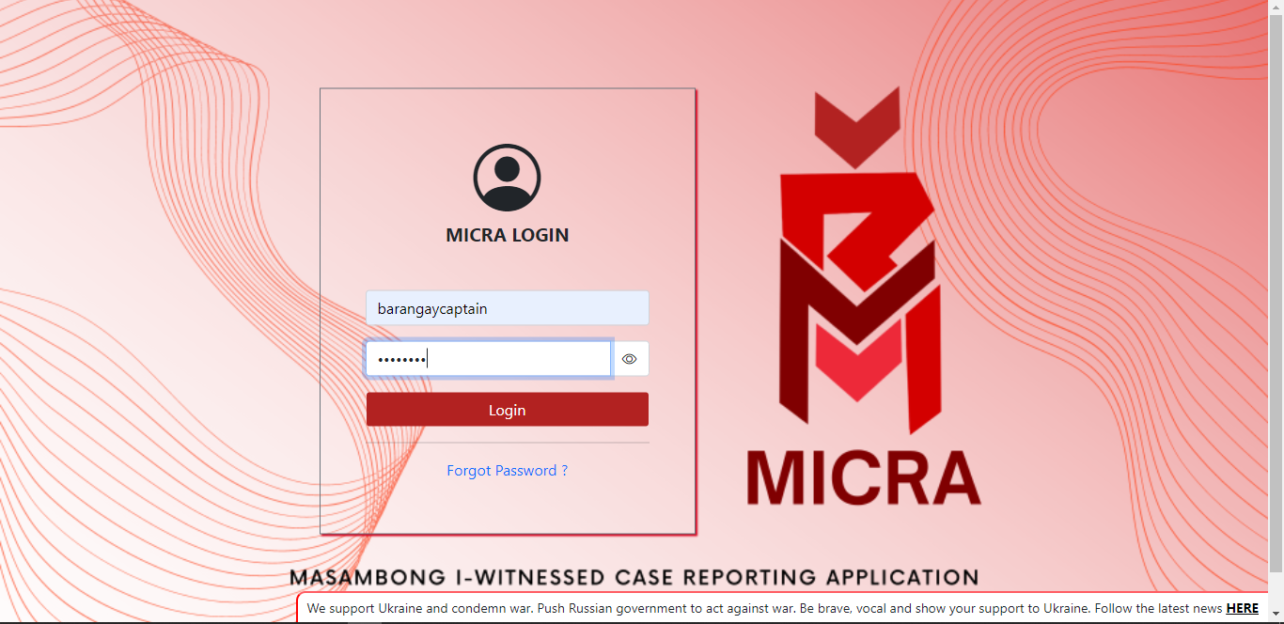

Barangay Captain MICRA Login

Barangay Captain Forgot Password

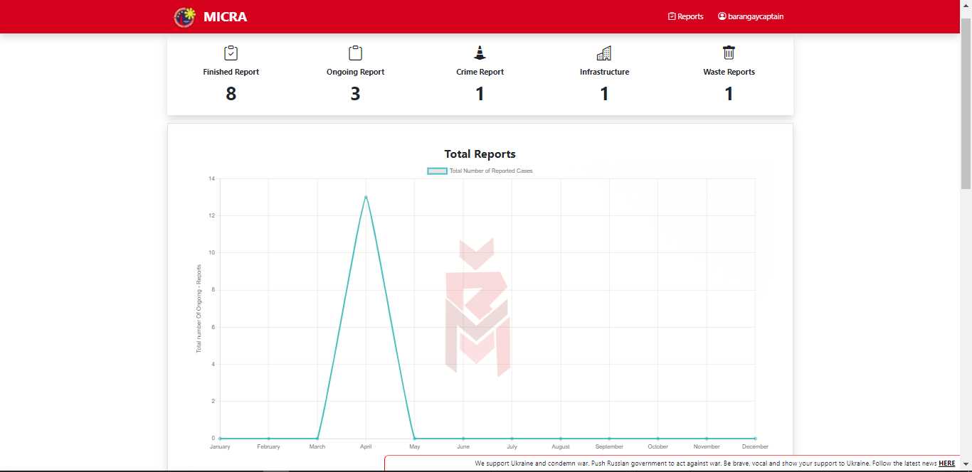

Barangay Captain Total Reports

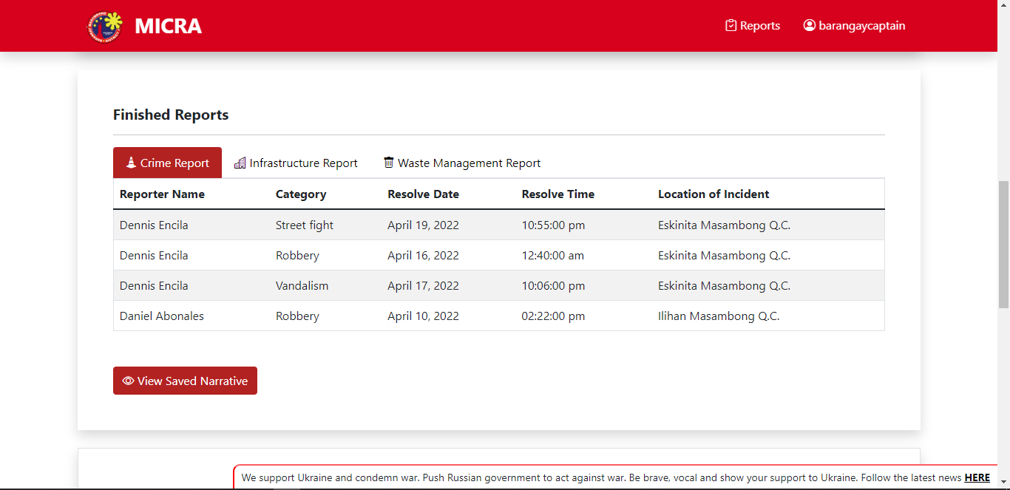

Barangay Captain Finished Reports

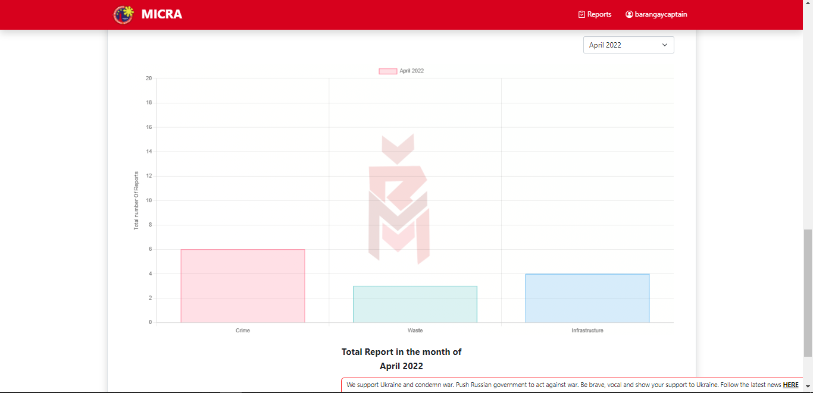

Barangay Captain Print Analytics

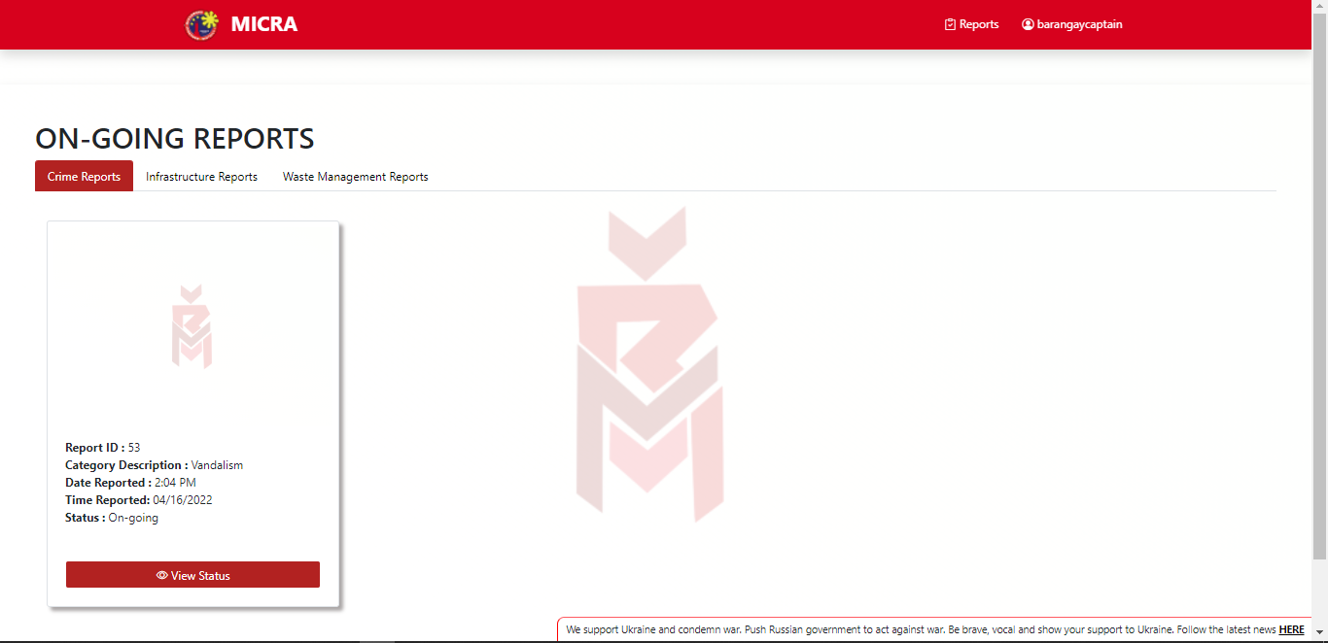

Barangay Captain Ongoing Reports for Crime,

Infrastructure, and Waste Management

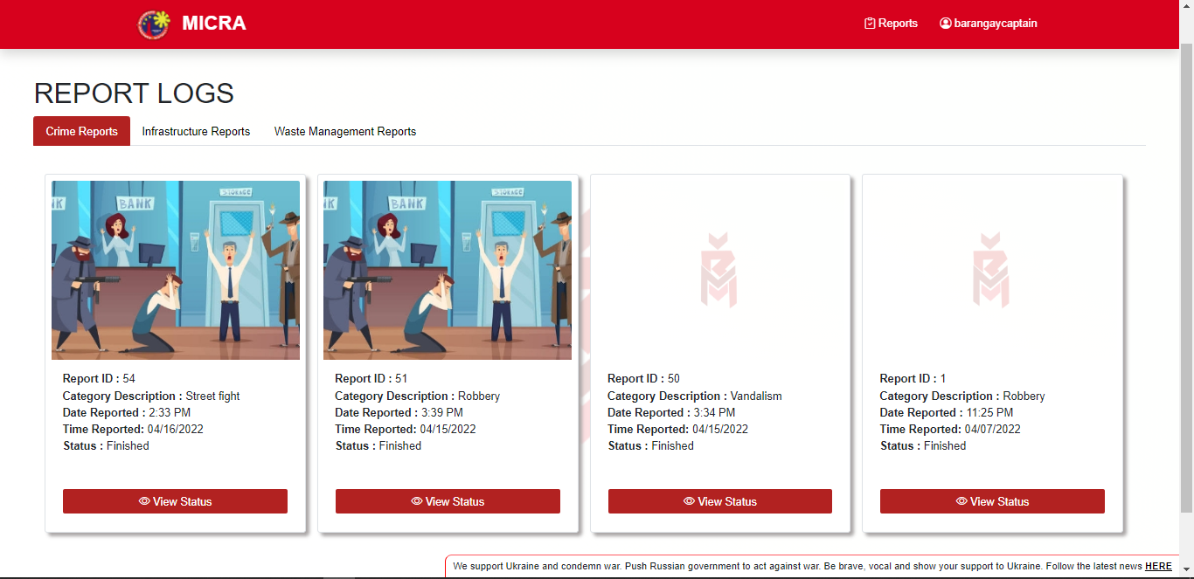Barangay Captain Report Logs for Crime, Infrastructure, 

and Waste Management

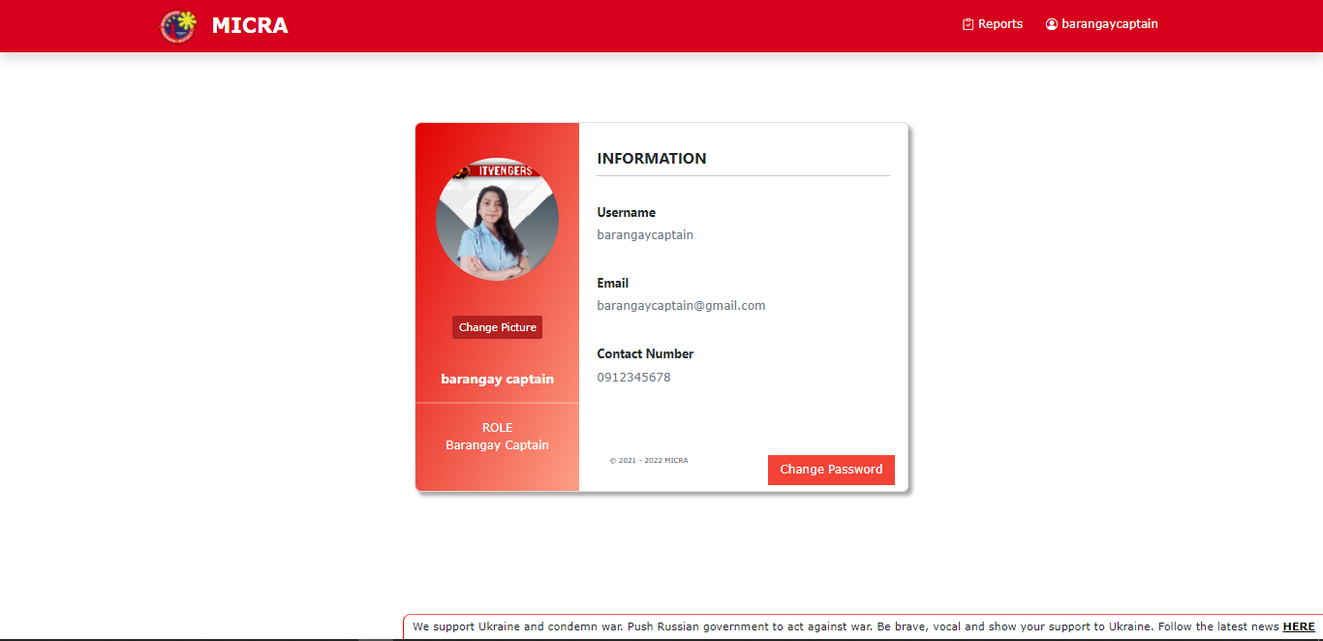

Barangay Captain Profile

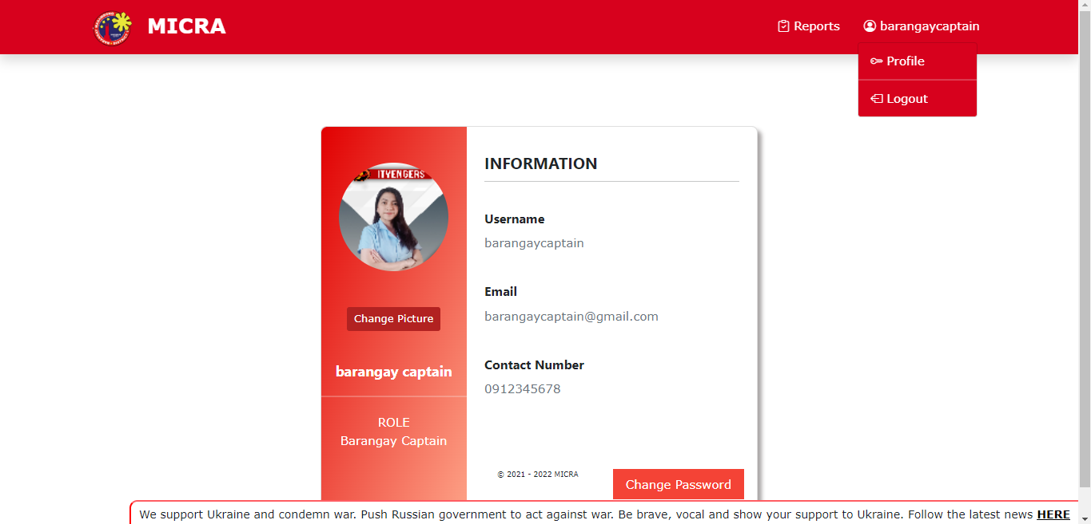

Barangay Captain Logout

If the Crime Head Admin wants to change their password, they must input their Current Password, New Password, and input again their New Password to confirm if it matches. There is a Confirm button if the Main Admin is satisfied with their password and close it if they're done.